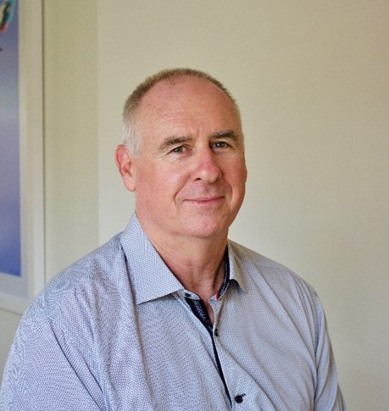

Geordie Thompson is one of our visiting consultants here at the Pelvic Health Clinic. Geordie is a Solution Focused Clinical Hypnotherapist with a keen interest in helping people with pain (sensation) issues and the related emotional responses such as anxiety.
Geordie provides a safe and empowering environment where challenges such as anxiety and depression can be resolved and reframed enabling the client to move forward with greater confidence and competence.
Geordie is an experienced developer of people’s potential and understands that in order to grow some challenges are necessary and useful. His calm and compassionate style enable clients to reconnect with their own resources in order to move through trauma and enjoy their post-traumatic growth.
Bookings can be made with Geordie by calling 0413 207 200
or emailing Geordie@hypnologicsolutions.com.au.

Dealing with Anxiety
Dealing with Depression
Coping with Persisting Pain
Want to get better at whatever you do? Improving Performance
See below……..

Listen to calming sessions
Calming Beach Walk
The Power Of Your Words

Are you anxious about your anxiety?
Dealing with Anxiety
The feeling of anxiety is a signal in your body that it is responding to a perceived threat. A good example is a student preparing for an exam or test. Their thoughts, especially negative ones create a perception of threat, and the body responds by releasing adrenaline and cortisol into the body. We all know that feeling of being slightly on edge and worried and the physical components of this are generated in the body. Our thoughts about the threat can also generate the physical response without the threat even being real.
My therapeutic approach helps you to discriminate between real and imagined threats and teaches you ways in which the extra energy can be made useful. By doing this you can calm your body down and create positive choices to deal with the real issues.
I look forward to help you develop calm, confidence, and a positive future.

Are you sick of worrying about your worry?
Depression is not a thing you have, but more a process that involves poor sleep, rumination, negative thinking and behaviours and a general orientation to things that happened in the past. Solution Focused Therapy helps you to shift your thinking to positive future goals and outcomes and breaks the pattern of negative thinking by putting you back in the control seat. I also teach you how to get yourself a good night’s sleep so you can start rebuilding that energy and motivation that helps you move along the road to better health and wellbeing. As you come to understand how these processes are developed you can begin to change them and in turn change your life.
I look forward to helping you let go of the past, put that smile back on your face and body and working forward to a bright future.

Coping with Persisting Pain
Pain is not a measure of tissue damage, pain is one of the protection signals of the body and its purpose is to protect the body and promote healing and sometimes the sensations can persist long after any tissue damage has fully recovered. Often the unconscious mind has a very good reason for giving you that signal when the event first occurs but sometimes needs to be convinced that the situation has now changed before it stops giving the signal. Fortunately, we can negotiate with the part of the mind driving the sensation and in many cases the pain can be dramatically reduced.
In cases where some uncomfortable sensation will remain part of you life it is important to identify ways of distancing yourself from the sensations and establishing an more comfortable way of thinking and moving.
I look forward to helping you reduce your sensations and enjoy life

Want to get better at whatever you do?
Improving Performance
High performance is both a physical and a mental state. You may have heard the phrase; training is 90% physical and 10% mental but performance is 10% physical and 90% mental. Basically, our training and experience is inextricably linked to our beliefs about ourselves and our performance.
We often hear about the high-level athlete who drops their bundle just before or during their event and even though their training has been sufficient to enable them to perform at the highest level, their mental strength does not support their physical skill.
Similarly, we all know someone who is super bright but constantly fails exams even though their knowledge of the topic was excellent.
I have training high level athletes for over 40 years and know how to tap into their internal mental and emotional landscapes in order to help them achieve their personal goal. It may seem unusual to suggest hypnotherapy in order to perform well however there is no separation between mind and body therefore just as you prepare your physical muscles for performance it is equally important to train your mind with your body in order to get the best results.
I can work with you to develop your inner skills to match the challenges that you face be they physical or intellectual.

